16.66: (See also Problems 16.70 and 16.74). Let 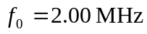 be the frequency of the generated wave. The frequency with which the heart wall receives this wave is 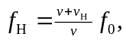 and this is also the frequency with which the heart wall re-emits the wave. The detected frequency of this reflected wave is
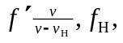 with the minus sign indicating that the heart wall, acting now as a source of waves, is moving toward the receiver. Combining, 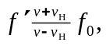 and the beat frequency is
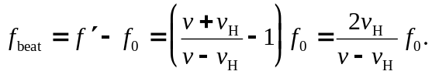

Solving for 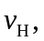
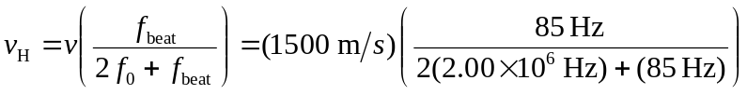
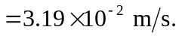
Note that in the denominator in the final calculation,  is negligible compared to 